Project Development Phase
Date | 13 July 2026
Team ID
Project Name | Visualizing Housing Market Trends: An Analysis of Sale Prices and Features using Tableau
Maximum Marks | 4 Marks

Data Preprocessing Steps
Step 1: Import the Dataset
- Imported the Housing Sales dataset (~21,609 records) into Tableau Public.
- Verified that all records and fields (Sale Price, Bedrooms, Bathrooms, Living Area, Lot Area, Floors, Waterfront, View, Grade, Condition, Year Built, Year Renovated, Zipcode, etc.) were imported successfully.
- Confirmed that the dataset was ready for preprocessing.
Step 2: Check for Missing Values
- Examined the dataset for null or blank values.
- Verified that important fields such as Sale Price, Bedrooms, Bathrooms, Living Area and Zipcode contained valid information.
- Missing values were handled appropriately to ensure accurate analysis.
Step 3: Remove Duplicate Records
- Checked the dataset for duplicate property records using the property ID.
- Removed duplicate entries to prevent inflated counts and incorrect market insights.
- Ensured that every property sale was represented only once.
Step 4: Validate Data Types
Ensured that each attribute had the correct data type.
  - Property ID → String
  - Sale Price → Number
  - Bedrooms → Number (Integer)
  - Bathrooms → Number (Decimal)
  - Living Area (Sqft) → Number
  - Lot Area (Sqft) → Number
  - Floors → Number (Decimal)
  - Waterfront → Categorical
  - View → Categorical
  - Grade / Condition → Categorical
  - Year Built → Number
  - Year Renovated → Number
  - Zipcode → Geographic/String
Step 5: Verify Data Consistency
- Checked for invalid or unrealistic values such as zero/negative sale price, zero bedrooms or bathrooms, or unrealistic living-area values.
- Standardized zipcode groupings, renovation-status categories, and grade/condition labels.
- Ensured consistency across all categorical fields before visualization.
Step 6: Prepare Calculated Fields
Created calculated fields required for dashboard analysis, including:
- Total Properties
- Average Sale Price
- Total Living / Basement Area
- House Age (current year − year built)
- Years Since Renovation
- Renovation Status (Renovated / Not Renovated flag)
- Sale Price Bins
- Zipcode Group
- KPI Measures for Dashboard
Step 7: Final Clean Dataset
- Verified that the cleaned dataset was complete and suitable for analysis.
- Confirmed that all preprocessing activities were completed successfully.
- The dataset was finalized for dashboard creation and business intelligence visualizations in Tableau Public.
Business Questions with Visualization
S.No. | Business Question | Visualization
1 | How many housing sale records are available for analysis after data preprocessing, what is the average sale price, and what is the total basement area across properties? | KPI Summary Panel (KPI Cards)
2 | How do total sales vary by the number of years since renovation? | Total Sales by Years Since Renovation (Bar Chart)
3 | How is house age distributed across renovated vs. non-renovated properties? | Distribution of House Age by Renovation Status (Pie Chart)
4 | How does house age vary by number of bathrooms, bedrooms and floors? | House Age Distribution by Bathrooms, Bedrooms & Floors (Bar Chart)

3. Visualizations:
KPI Summary Panel
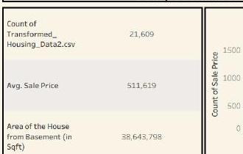

Total Sales by Years Since Renovation
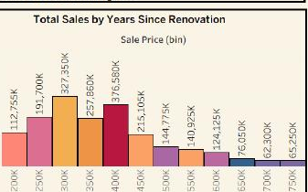

Distribution of House Age by Renovation Status
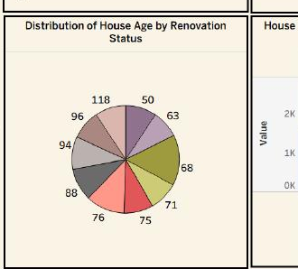
House Age Distribution by Bathrooms, Bedrooms & Floors
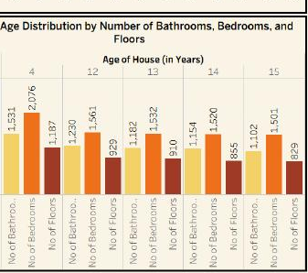

Dashboard:
Comprehensive House Data Analysis — published Tableau Public dashboard combining the KPI summary panel with all supporting visualizations.
